From Zero Drupal Knowledge to Secure AKS Frontend:
Workload Identity, Azure Files, and TLS Ingress (with Real Errors)
I don’t write PHP and I’m not a Drupal developer. But Kubernetes didn’t really care. Once I understood Pods, Deployments, Services, Ingress, and a bit of Azure plumbing, I could take an existing Drupal image, mount persistent storage, wire it to Azure Key Vault and Azure Files, and expose it securely over HTTPS.
This article walks through that journey using a small GitHub repo and a set of real screenshots from a troubleshooting session. The same pattern works for almost any frontend framework—React, Angular, Vue, Drupal, or something home‑grown. You don’t need to know the language running inside the container; you just need to understand how Kubernetes connects all the pieces.

Repository layout
aks-secure-storage-and-ingress/
├─ README.md
├─ manifests/
│ ├─ ns-quota.yaml # Namespace ResourceQuota + LimitRange
│ ├─ service-account.yaml # sa-drupal with workload identity annotations
│ ├─ secret-class-provider.yaml # SecretProviderClass (Key Vault → k8s secret)
│ ├─ azure-files-pod.yaml # Drupal Deployment + Azure Files + KV CSI
│ ├─ ingress-service.yaml # ClusterIP Service (drupal-service)
│ ├─ ingress-service-backend.yaml # Ingress with host/TLS/backend rules
│ └─ dns-pod-test.yaml # Optional DNS/debug pod
├─ scripts/
│ ├─ 01-user-assigned-identity.sh # Create UAMI + basic wiring
│ ├─ 02-federate-credential.sh # Federated credential (AKS OIDC → UAMI)
│ ├─ 03-akv-generate-selfsigned-cert.sh # Self-signed cert directly in Key Vault
│ ├─ 03-local-self-signed.sh # Local self-signed cert → tls.{crt,key} → k8s secret
│ └─ azure-files-deployment.sh # Orchestrates full Azure Files + ingress deployment
└─ docs/
└─ aks-pods-deployments-ingress-certificates-v2.docx # Design notes / earlier version

1. Architecture at a glance
Let’s start with the big picture. The goal is to run Drupal on AKS with:
• Azure AD Workload Identity for pod-to-Azure authentication
• Azure Files as a persistent volume for Drupal’s files directory
• Azure Key Vault storing the storage account name and key, accessed via Secrets Store CSI
• An NGINX ingress controller terminating HTTPS with a certificate you received as a .pfx file
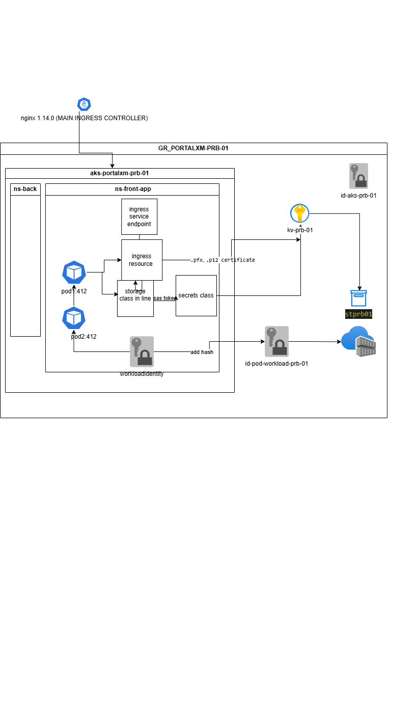
Figure 1 – High‑level AKS architecture: ingress controller, namespace, workload identity, Key Vault, and Azure Files.
Everything in the rest of the article supports this picture. We’ll move from certificates, to identities, to Secrets Store CSI, to Deployments, Services, and Ingress, and finally walk through real‑world errors that you are very likely to hit along the way.

2. Certificates: from PFX to Kubernetes TLS secret
Most corporate environments hand you a .pfx file and say “here’s the certificate for your HTTPS site”. Kubernetes and NGINX expect a TLS secret containing a PEM‑encoded certificate and private key. The first step is converting that PFX into the pair of files Kubernetes understands.
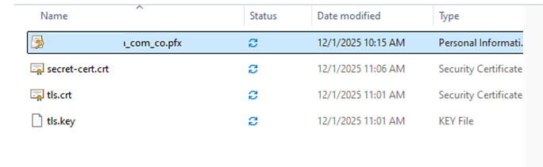
Figure 2 – The original PFX file and the extracted tls.crt / tls.key on disk.
Using OpenSSL (I used WSL, but any shell works), you split the PFX like this:
openssl pkcs12 -in portalxm-prb_xm_com_co.pfx -nocerts -nodes -out tls.key -legacy
openssl pkcs12 -in portalxm-prb_xm_com_co.pfx -clcerts -nokeys -out tls.crt -legacy
Then you create a Kubernetes TLS secret in the same namespace as your app:
kubectl create secret tls drupal-portalxmprb-tls \
--cert=tls.crt \
--key=tls.key \
-n ns-portalxmdrupal
The ingress resource will later reference this secret under its tls section, so NGINX can terminate HTTPS for your site.

3. Workload identity and SecretProviderClass
The next building block is identity. Pods need to read secrets from Key Vault (for example, the Azure Storage account key used by the Azure File CSI driver). Instead of baking keys into Kubernetes secrets ahead of time, we use Azure AD Workload Identity plus the Secrets Store CSI driver to fetch them dynamically.

Figure 3 – Inspecting the SecretProviderClass that maps Key Vault secrets into a Kubernetes secret for Azure Files.
The SecretProviderClass ties together:
• The Azure Key Vault name
• The workload identity client ID and tenant ID
• The list of objects (secrets) to fetch (e.g., drupal-storage-name and drupal-storage-key)
• The Kubernetes secret to synchronize into (drupal-storage-key), which the Azure File CSI driver will later consume.
Figure 4 – Verifying that the Secrets Store CSI provider is installed and that the SecretProviderClass exists in the target namespace.
At this point, the moving pieces are:
1. A user‑assigned managed identity with access to Key Vault and the Storage Account.
2. A federated credential that allows the Kubernetes ServiceAccount sa-drupal to obtain tokens as that identity.
3. The SecretProviderClass instructing the CSI driver which Key Vault secrets to map into a Kubernetes secret.

4. Deployments, Services, and Ingress: wiring Drupal to the edge
With identity and secrets in place, we can finally talk about Pods. We never run a naked Pod; instead we use a Deployment that guarantees at least one replica of our drupal container is always running, with the right volumes mounted.
The matching Service exposes those Pods on a stable virtual IP inside the cluster. The Ingress then connects external HTTPS traffic for portalxm‑prb.xm.com.co to that Service. When everything works, kubectl get endpoints shows a Pod IP behind the Service.
Figure 5 – Service endpoints initially empty (no backing Pods Ready yet).
Figure 6 – The same Service once the Drupal Deployment is healthy: Pod IP and port 80 are now registered as endpoints.
These two screenshots are a before/after story. At first, the Service exists but has no endpoints, so any traffic sent to it will fail. Once the Deployment pod becomes Ready, the endpoint controller registers that Pod’s IP and container port (80 in this case), and the network path inside the cluster is complete.
Figure 7 – Inspecting the ingress and service: note the ingress address, host, and the service port configuration.
The ingress exposes ports 80 and 443 at the load balancer level, but it forwards to the service on whatever port you configure (typically 80 for HTTP inside the cluster). Later we’ll see what happens when the ingress backend port and the service port do not match.

5. Real errors you will hit (and how to fix them)
The screenshots in this section come from real mistakes made while wiring this environment. Seeing them up front makes it easier to recognize what’s going on in your own clusters.

5.1 ImagePullBackOff: no permission to pull from the container registry
Figure 8 – Pod stuck in ImagePullBackOff because the node identity cannot pull from the container registry.
ImagePullBackOff means the kubelet repeatedly tried to pull the image and failed. In AKS with a private Azure Container Registry (ACR), the usual root cause is that the node’s managed identity (the AKS kubelet identity) does not have the AcrPull role on the registry.
Before assigning any roles, confirm which identity AKS uses to pull images.
How to confirm:
1. kubectl describe pod <pod-name> Look at the Events section. You will see errors such as:
- Error: ErrImagePull
- Back-Off Pulling Image
- Failed to Pull Image
Figure 9 – Failed to pull images from pod description error

2. Check the AKS Kubelet Identity
(Workload Identity is not used for ACR pulls.)
az aks show \
--resource-group <RG> \
--name <AKS_NAME> \
--query "identityProfile.kubeletidentity.objectId" \
-o tsv
If this returns an objectId, that is the identity your cluster uses to pull images from ACR.
👉 AKS always pulls images using the kubelet identity. Workload Identity is only for pod-to-Azure authentication (Key Vault, Storage, etc.), never for ACR access.
export KUBELET_IDENTITY_OID=$(az aks show \
--resource-group <RG> \
--name <AKS_NAME> \
--query "identityProfile.kubeletidentity.objectId" \
-o tsv)

echo "Kubelet Identity Object ID: $KUBELET_IDENTITY_OID"
3. In Azure, assign AcrPull on the ACR to that identity:
az role assignment create \
--assignee <kubelet-or-node-identity-id> \
--role AcrPull \
--scope /subscriptions/<sub>/resourceGroups/<rg>/providers/Microsoft.ContainerRegistry/registries/<acr-name>
Once the role assignment is in place and propagated, deleting the failing Pod (or restarting the Deployment) should allow the pull to succeed.

5.2 Ports and Azure Policy: service vs. ingress backend mismatch
Figure 9 – Azure Policy warning: port 80 for service drupal-service has not been allowed.
In some clusters, a security policy forbids exposing service ports on 80. At the same time, the Drupal container still listens on 80 internally. A naive fix is to change both the service port and targetPort to 443, but that breaks traffic because the container is still listening on 80.
The correct pattern is:
• Keep the container listening on 80 (containerPort: 80).
• Configure the Service with port: 443 but targetPort: 80.
• Configure the Ingress backend to send traffic to service port 443.
This satisfies the policy (no service directly on port 80) while still sending traffic to the right container port. If ingress and service ports don’t match (for example, ingress sends to port 80 but the service only exposes 443), you’ll see 502/503 errors from NGINX and no endpoints being hit.

5.3 Missing endpoints: Service created, but no Pods backing it
Another very common issue is a Service with no endpoints. kubectl get svc looks fine, but kubectl get endpoints drupal-service shows <none>. In that state, any traffic routed to the Service will fail because there’s nothing behind it.
The fix is always to check labels and pod readiness:
• Ensure the Service selector (e.g., app: drupal) matches the labels on the Pods created by the Deployment.
• Ensure at least one Pod is Ready. CrashLoopBackOff Pods do not become endpoints.
Once the Deployment is fixed and at least one Pod is Ready, kubectl get endpoints will show entries like 10.244.3.148:80, as in Figures 5 and 6.

5.4 Secrets Store CSI driver not installed or misconfigured
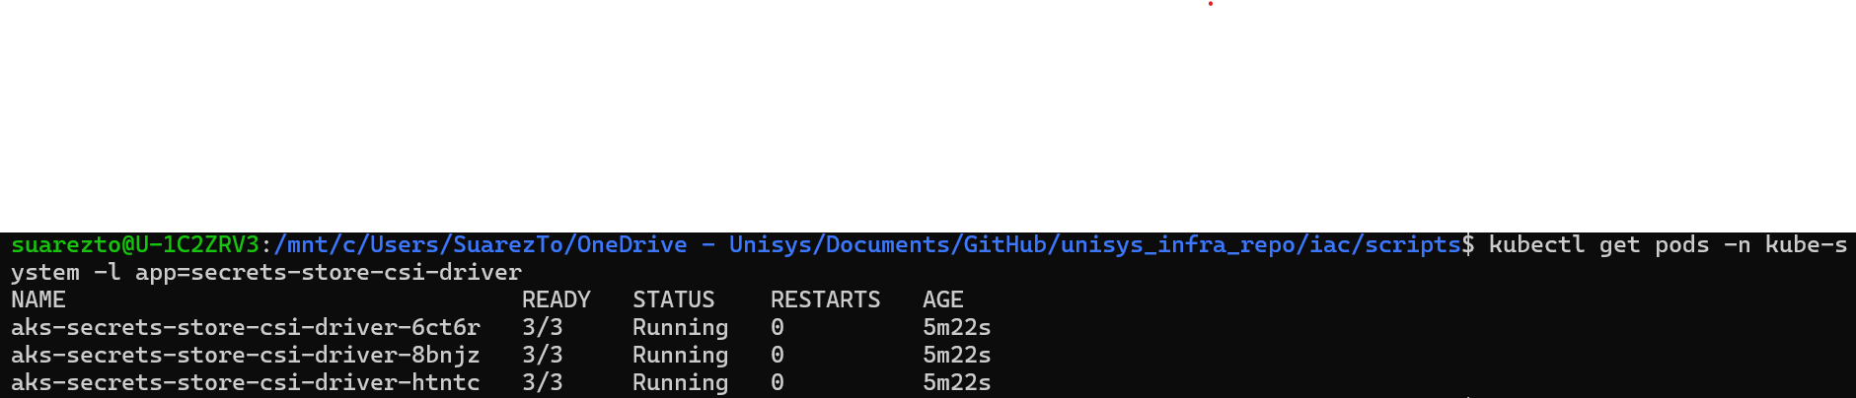
Figure 10 – secrets-store-csi-driver pods running successfully in the kube-system namespace.
Earlier in the journey, applying the SecretProviderClass failed with an error saying the kind SecretProviderClass did not exist. That message means the Secrets Store CSI CRDs are not installed—usually because the azure-keyvault-secrets-provider addon is disabled.
To fix it in AKS:
az aks enable-addons \
--addons azure-keyvault-secrets-provider \
--resource-group "$RESOURCE_GROUP" \
--name "$AKS_NAME"
After a few minutes, kubectl get pods -n kube-system -l app=secrets-store-csi-driver should show Running pods, as in Figure 10, and kubectl get secretproviderclass in your app namespace should succeed.

6. End-to-end verification checklist
Once everything is wired up, I like to run a short checklist to make sure the path from browser to container is truly complete:
1. Certificates
• kubectl get secret drupal-portalxmprb-tls -n ns-portalxmdrupal
• Optionally decode the certificate and inspect the subject and expiry.
2. Workload identity and Key Vault
• az role assignment list for the managed identity on Key Vault and the Storage Account.
• kubectl describe secretproviderclass azure-file-secret-provider -n ns-portalxmdrupal.
3. Secrets Store CSI and storage
• kubectl get pods -n kube-system -l app=secrets-store-csi-driver
• kubectl get secret drupal-storage-key -n ns-portalxmdrupal
4. Deployment and endpoints
• kubectl get deployment drupal-deployment -n ns-portalxmdrupal
• kubectl get pods -n ns-portalxmdrupal -l app=drupal
• kubectl get endpoints drupal-service -n ns-portalxmdrupal
5. Ingress
• kubectl get ingress drupal-ingress -n ns-portalxmdrupal -o wide
• curl -k https://portalxm-prb.xm.com.co from a machine that can resolve the host.

7. Closing thoughts: Kubernetes as a universal frontend platform
The most interesting part of this whole exercise is that it never required knowing Drupal internals. Kubernetes turned Drupal into “just another container” that needed storage, identity, and network plumbing. The same repo structure and troubleshooting playbook would work for almost any frontend stack.
Once you’re comfortable reading kubectl output, following the path from Ingress → Service → Endpoints → Pod, and wiring Workload Identity and Secrets Store CSI into the mix, the specific application framework becomes almost incidental. You can focus on the platform pieces—security, storage, and routing—and let the app teams focus on the language and runtime they care about.
That’s the real power of Kubernetes in environments like AKS: a consistent story for frontends, regardless of whether they’re written in PHP, Node.js, Java, or something that hasn’t even been invented yet.

